**sCart**

**Objective**

Implement a shopping cart using the best practices and a near production code where user can do the following things

**1. Login screen**

1. User should be able to login using the API’s
   1. Username: amigo
   2. Password: delta

**2. Product listing page**

* 1. User should be able to search the product
  2. User should be able to filter the products based on color, brand , price, discount
  3. User should be able to see the product list as tiles with its details as ProductA, BrandA, discount, colour, price
  4. User can see his name once he logs in

1. **Add to cart**
   1. User should be able to add products to the cart using add to cart button and see the carts count increasing

**4. Error messages**

1. API can fail so should be handled
2. Login error message for username and password

**Tech**

What we are looking for ?

1. React or any other framework / library which you are good in
2. Any state management library or not (you should have a justification)
3. Any side-effect management library like saga, thunk etc. (you should have a justification)
4. Or if there is any better way of handling side-effects (eg: Hooks)
5. Spend some time in building the UI take inspiration from other ecommerce sites

**Note**The code should be near production ready using best practices. What should you do ?

1. Don’t use any predefined css frameworks like bootstrap or material components. We expect you to write the css on your own.
2. The application should be responsive till iPad 1024 x 768.
3. You can use some linters to beautify your code.
4. You can use some helper JS libraries like lodash, react router etc. but use them wisely.
5. You can use css or any pre-processors.
6. We expect you to write unit test cases so that you are sure it works.
7. Try to make the layout as close to the wireframe as possible.
8. You can stick with the Create React App so you can get started quickly.
9. Feel free to optimize your code.
10. There’s no hurry try to give your best shot at solving problem and writing readable code

If there are any assumptions that you might have taken while solving the assignment feel free to write them in **readme** **file**

**API to use**

1. GET Product Listing: localhost[/products](https://xebia-scart.herokuapp.com/products)

2. Product Search by name: localhost[/products?title=provogue](https://xebia-scart.herokuapp.com/products?title=provogue)

3. GET Product Filters: localhost[/filters](https://xebia-scart.herokuapp.com/filters)

4. User Login:localhost[/users?username=amigo](https://xebia-scart.herokuapp.com/users?username=amigo)

**How to submit**

1. Upload the code on GitHub.
2. Make sure you maintain the commit history with appropriate commit messages.

**Screenshots**

1. **Login Screen**

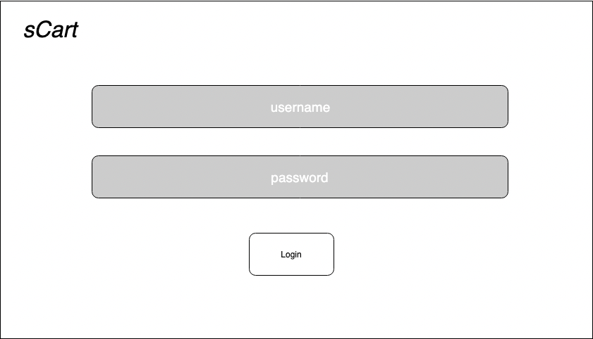

1. **Product Listing**

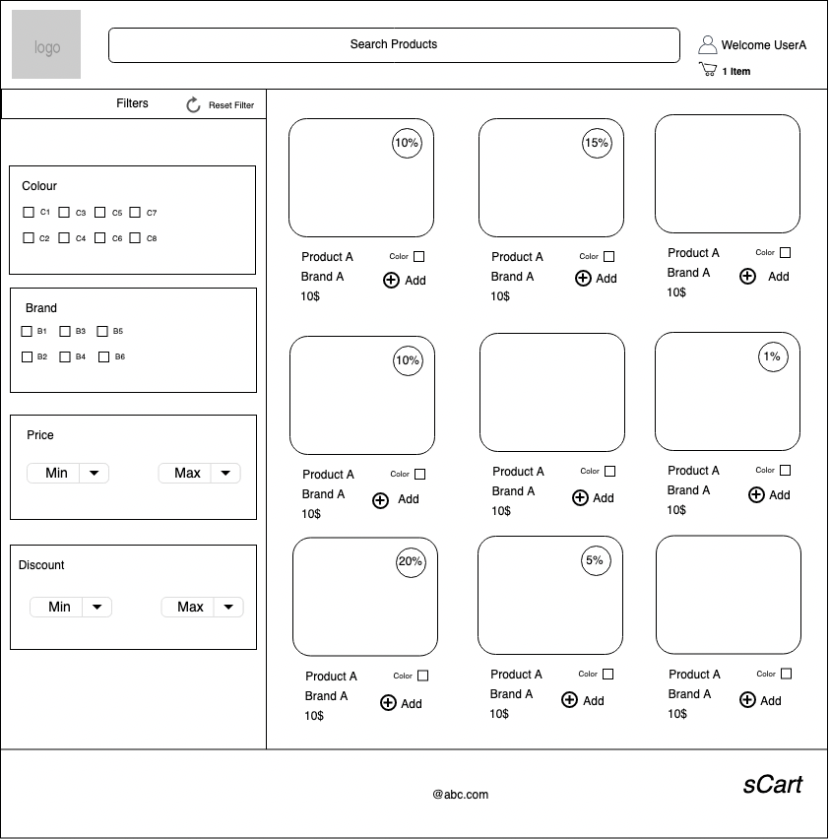

**👾**

**\*\* Happy coding \*\***